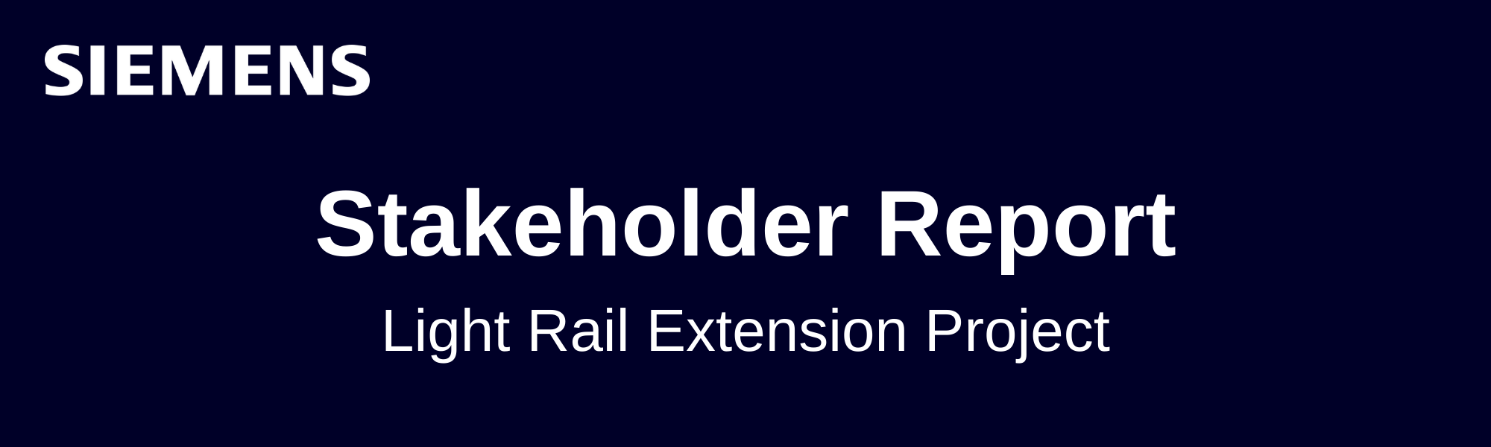

Project Overview
Project Name: Light Rail Extension Project
Phase: Construction
Reporting Period: Past 60 Days

Estimate at Completion (EAC)
Target Budget: $100M
Forecasted EAC: $108M
Analysis: The project is forecasted to exceed the original budget by $8 million, due largely to persistent overspending in electrical systems and ongoing vendor issues. Track installation and station construction remain mostly on target, while additional costs have been incurred in electrical procurement and routine management expenses.

Performance Summary
Cost Performance:
- CPI = 0.89 (At Risk)
- Cost overruns have occurred in multiple areas:
- Electrical Systems: +$4M variance due to vendor issues and rework.
- Track Installation: +$1.5M due to overtime and labor cost increases.
- Other Costs: +$0.5M due to higher compliance-related expenses.
- These overspends outweigh the savings from station construction (–$1M).
- Overall, cost performance is below expectations and requires corrective action.

Schedule Performance:
- SPI = 1.03 (On Track)
- Track work is slightly ahead of schedule; station construction remains on planned pace.
- No immediate schedule delays reported, but unresolved electrical issues could create downstream bottlenecks if not addressed soon.

Risk Management:
- Risk Closure Rate: 62% (Needs Attention)
- Key risks in electrical integration remain unresolved and pose significant threat to both cost and schedule stability.
- Risk mitigation efforts need acceleration, especially with the electrical vendor.

Risks and Opportunities
Key Risks:
- Electrical System Integration Issues:
- Largest driver of cost variance (+$4M).
- Risk of further delays and rework if vendor performance does not improve.
- Vendor Performance & Procurement Delays:
- Ongoing negotiations signal instability in supply and quality assurance.
- May require contingency planning.
- Potential Schedule Bottlenecks:
- Although SPI is healthy now, unresolved electrical work can impact future phases (testing, commissioning).
Opportunities:
- Station Construction Efficiencies:
- Underspend of $1M indicates strong procurement management.
- Opportunity to replicate these efficiencies in other work packages.
- Track Work Ahead of Schedule:
- Gains here could help buffer future delays if other areas slip.
- Opportunity to reallocate experienced labor teams to struggling areas.
- Vendor Negotiations:
- Current renegotiations may provide a chance to secure better pricing or contractual accountability.

Recommendations
- Escalate Electrical Vendor Mitigation & Add Contingency Measures:
- Enforce performance clauses, increase quality inspections, and evaluate backup vendors.
- Strengthen Cost Controls Across High-Variance Packages:
- Deploy tighter tracking on overtime, procurement overruns, and rework.
- Accelerate Risk Closure with Cross-Functional Coordination:
- Increase coordination between engineering, procurement, and compliance teams to clear bottlenecks.

Conclusion
While the project shows positive schedule progress, cost overruns and unresolved technical risks remain a challenge. Forecasts indicate continued pressure on the budget, with key electrical and procurement areas needing urgent attention. Ongoing monitoring and proactive mitigation will be essential to ensure project success and stakeholder satisfaction.

